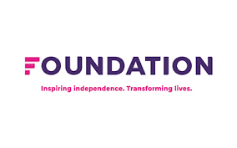
Please complete this form and send via email to: preventionenquires@foundationuk.org

I am interested to find out more about Foundation +Choices Perpetrator Prevention Toolkit Workshops and I am providing my contact details, as a professional, to be contacted for more information and to discuss a possible booking.

Contact Name:

Position:

Organisation Name:

Contact Email:

Contact Number:

